Create your own paper mâché dinosaur  - find out 3 facts about it to share with the class.  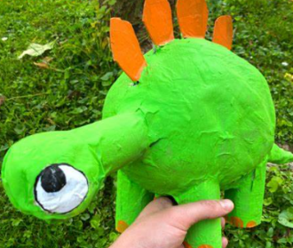 |  | Create your own fossil:  - When was is discovered?  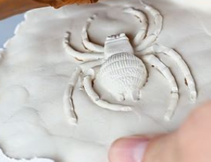  - Which palaeologist discovered it?
Create your own dinosaur habitat:  - What did they eat?  - Are they a herbivore or carnivore?  - Where did they sleep?  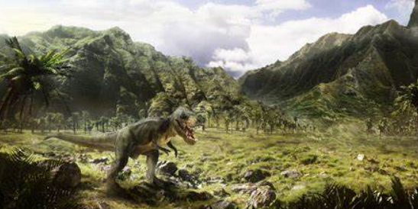 | Understanding The World  Homework Grid  Term 3: Dinosaurs
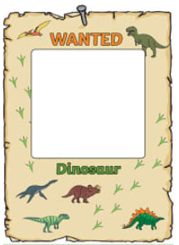
Wanted Dinosaur Poster!
- A picture of your dinosaur
- Describe what it looks like eg: it is big and bad.

